**CASE STUDY PROJECT MANAGEMENT**

**CREATE DATABASE SCHEMA :**

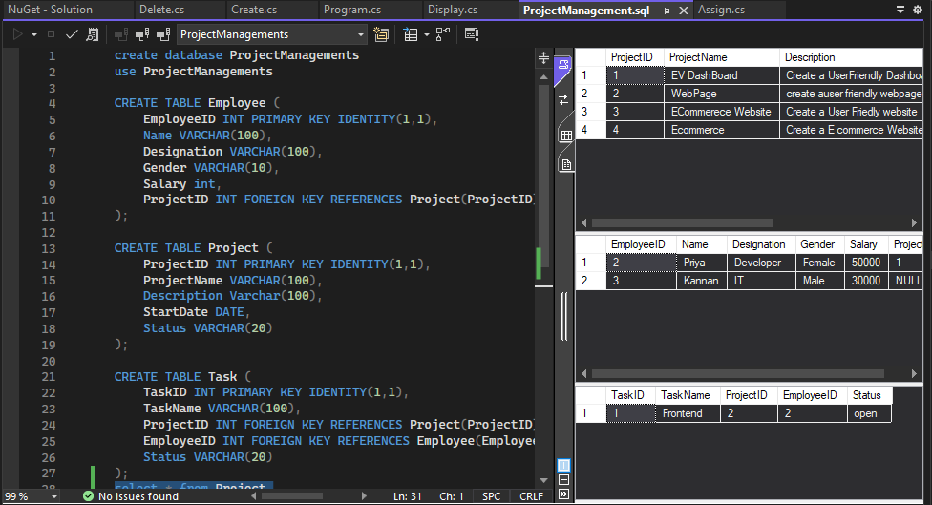

**CREATE MODELS:**

1. **Employee**

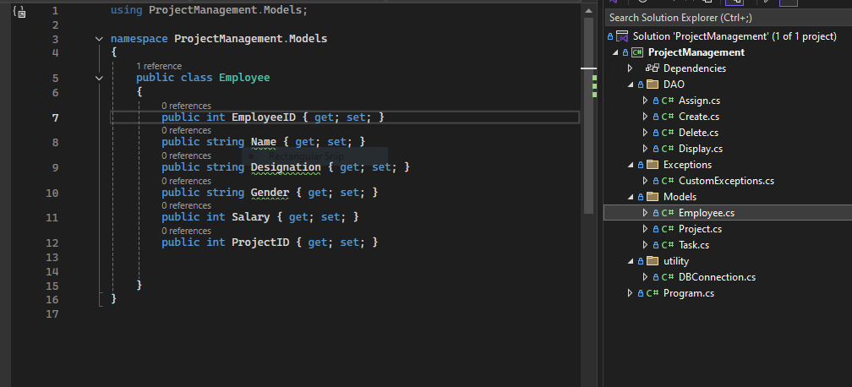

1. **Project**

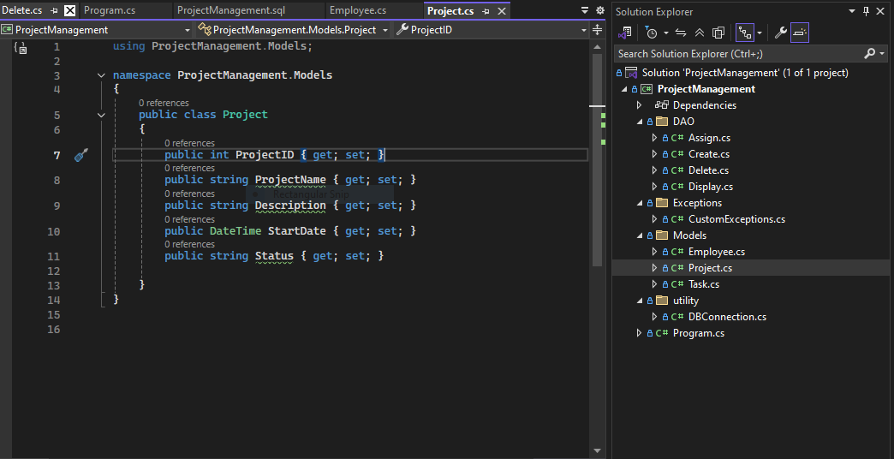

1. **Task**

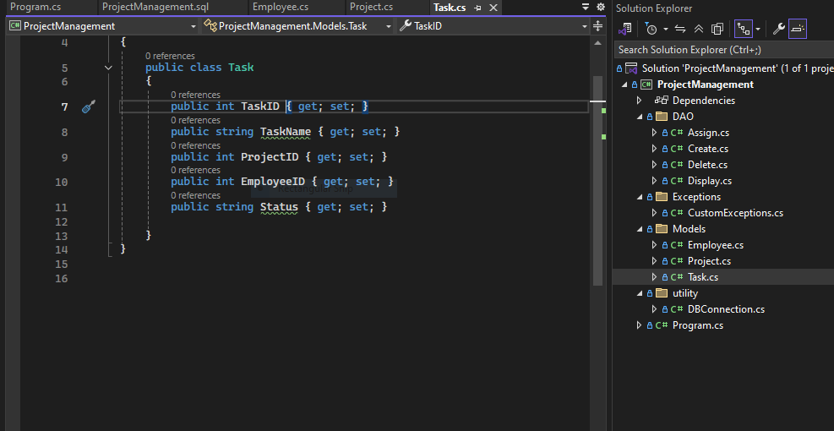

**CREATE UTILITY**

1. **DBConnection**

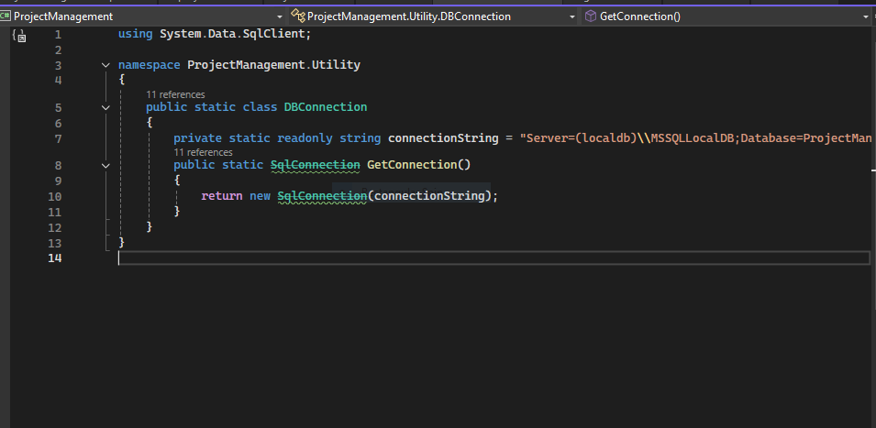

**CREATE DAO**

1. **Assign**

using ProjectManagement.Exceptions;

using ProjectManagement.Models;

using ProjectManagement.Utility;

using System;

using System.Data.SqlClient;

using System.Threading.Tasks;

namespace ProjectManagement.DAO

{

public class Assign

{

public static void AssignProject()

{

Console.Write("Enter Employee ID to Assign Project: ");

int employeeid = int.Parse(Console.ReadLine());

Console.Write("Enter ProjectID: ");

int projectid = int.Parse(Console.ReadLine());

using SqlConnection conn = DBConnection.GetConnection();

string query = "UPDATE Employee SET ProjectID = @projectid WHERE EmployeeID = @employeeid";

using SqlCommand cmd = new SqlCommand(query, conn);

cmd.Parameters.AddWithValue("@employeeid", employeeid);

cmd.Parameters.AddWithValue("@projectid", projectid);

conn.Open();

int result = cmd.ExecuteNonQuery();

Console.WriteLine($"{result} Project Assigned Sucessfully.");

}

public static void AssignTask()

{

Console.Write("Enter Task ID to Assign Project and Employee: ");

int taskid = int.Parse(Console.ReadLine());

Console.Write("Enter ProjectID: ");

int projectid = int.Parse(Console.ReadLine());

Console.Write("Enter EmployeeID: ");

int employeeid = int.Parse(Console.ReadLine());

using SqlConnection conn = DBConnection.GetConnection();

string query = "UPDATE Task SET ProjectID = @projectid, EmployeeID = @employeeid WHERE TaskID = @taskid";

using SqlCommand cmd = new SqlCommand(query, conn);

cmd.Parameters.AddWithValue("@taskid", taskid);

cmd.Parameters.AddWithValue("@employeeid", employeeid);

cmd.Parameters.AddWithValue("@projectid", projectid);

conn.Open();

int result = cmd.ExecuteNonQuery();

Console.WriteLine($"{result} Task Assigned Sucessfully.");

}

}

}

1. **Create**

using ProjectManagement.Models;

using ProjectManagement.Utility;

using System;

using System.Data.SqlClient;

namespace ProjectManagement.DAO

{

public class Create

{

public static void CreateEmployee()

{

Console.Write("Enter Full Name: ");

string name = Console.ReadLine();

Console.Write("Enter Designation: ");

string designation = Console.ReadLine();

Console.Write("Enter Gender: ");

string gender = Console.ReadLine();

Console.Write("Enter Salary: ");

int salary = int.Parse(Console.ReadLine());

int EmployeeID = 0;

using SqlConnection conn = DBConnection.GetConnection();

// Insert Employee

string studentQuery = "INSERT INTO Employee (Name,Designation,Gender,Salary) OUTPUT INSERTED.EmployeeID VALUES (@name, @designation,@gender,@salary)";

using SqlCommand cmd = new SqlCommand(studentQuery, conn);

cmd.Parameters.AddWithValue("@name", name);

cmd.Parameters.AddWithValue("@designation", designation);

cmd.Parameters.AddWithValue("@gender", gender);

cmd.Parameters.AddWithValue("@salary", salary);

conn.Open();

EmployeeID = (int)cmd.ExecuteScalar();

conn.Close();

}

public static void CreateProject()

{

Console.Write("Enter ProjectName: ");

string projectname = Console.ReadLine();

Console.Write("Enter Description: ");

string description = Console.ReadLine();

Console.Write("Enter Start Date (YYYY-MM-DD): ");

string startdate = Console.ReadLine();

Console.Write("Enter Status: ");

string status = Console.ReadLine();

int ProjectID = 0;

using SqlConnection conn = DBConnection.GetConnection();

// Insert Project

string studentQuery = "INSERT INTO Project ( ProjectName,Description,StartDate,Status) OUTPUT INSERTED.ProjectID VALUES (@projectname, @description,@startdate,@status)";

using SqlCommand cmd = new SqlCommand(studentQuery, conn);

cmd.Parameters.AddWithValue("@projectname", projectname);

cmd.Parameters.AddWithValue("@description", description);

cmd.Parameters.AddWithValue("@startdate", startdate);

cmd.Parameters.AddWithValue("@status", status);

conn.Open();

ProjectID = (int)cmd.ExecuteScalar();

conn.Close();

}

public static void CreateTask()

{

Console.Write("Enter Task: ");

string taskname = Console.ReadLine();

//Console.Write("Enter ProjectID: ");

//int projectid = int.Parse(Console.ReadLine());

//Console.Write("Enter EmployeeID: ");

//int employeeid = int.Parse(Console.ReadLine());

Console.Write("Enter Status: ");

string status = Console.ReadLine();

int TaskID = 0;

using SqlConnection conn = DBConnection.GetConnection();

// Insert Task

string studentQuery = "INSERT INTO Task ( TaskName,Status) OUTPUT INSERTED.TaskID VALUES (@taskname, @status)";

using SqlCommand cmd = new SqlCommand(studentQuery, conn);

cmd.Parameters.AddWithValue("@taskname", taskname);

//cmd.Parameters.AddWithValue("@projectid", projectid);

//cmd.Parameters.AddWithValue("@employeeid", employeeid);

cmd.Parameters.AddWithValue("@status", status);

conn.Open();

TaskID = (int)cmd.ExecuteScalar();

conn.Close();

}

internal bool CreateEmployee(Employee emp)

{

throw new NotImplementedException();

}

}

}

1. **Delete**

using ProjectManagement.Models;

using ProjectManagement.Utility;

using System;

using System.Data.SqlClient;

namespace ProjectManagement.DAO

{

public class Display

{

public static void DisplayEmployee()

{

using SqlConnection conn = DBConnection.GetConnection();

string query = "SELECT * FROM Employee";

using SqlCommand cmd = new SqlCommand(query, conn);

conn.Open();

using SqlDataReader reader = cmd.ExecuteReader();

Console.WriteLine("\nEmployee Details:");

while (reader.Read())

{

Console.WriteLine($"EmployeeID: {reader["EmployeeID"]}, Name: {reader["Name"]}, Designation: {reader["Designation"]}, Gender: {reader["Gender"]},Salary: {reader["Salary"]},ProjectID: {reader["ProjectID"]}");

}

}

public static void DisplayProject()

{

using SqlConnection con = DBConnection.GetConnection();

string query = "SELECT * FROM Project";

using SqlCommand cmd = new SqlCommand(query, con);

con.Open();

using SqlDataReader reader = cmd.ExecuteReader();

Console.WriteLine("\nProject Details:");

while (reader.Read())

{

Console.WriteLine($"ProjectID: {reader["ProjectID"]}, ProjectName: {reader["ProjectName"]},Description: {reader["Description"]}, StartDate: {reader["StartDate"]},Status: {reader["Status"]}");

}

}

public static void DisplayTask()

{

using SqlConnection con = DBConnection.GetConnection();

string query = "SELECT * FROM Task";

using SqlCommand cmd = new SqlCommand(query, con);

con.Open();

using SqlDataReader reader = cmd.ExecuteReader();

Console.WriteLine("\nTask Details:");

while (reader.Read())

{

Console.WriteLine($"TaskID: {reader["TaskID"]}, TaskName: {reader["TaskName"]},ProjectID: {reader["ProjectID"]}, EmployeeID: {reader["EmployeeID"]},Status: {reader["Status"]}");

}

}

public static void DisplayProjectAssigned()

{

string query = @"

SELECT p.ProjectId, p.ProjectName, e.Name, t.TaskName

FROM Task t

JOIN Employee e ON e.EmployeeID = t.EmployeeID

JOIN Project p ON p.ProjectID = t.ProjectID";

using SqlConnection conn = DBConnection.GetConnection();

using SqlCommand cmd = new SqlCommand(query, conn);

conn.Open();

SqlDataReader reader = cmd.ExecuteReader();

Console.WriteLine("\nProjects Assigned");

while (reader.Read())

{

Console.WriteLine($"ProjectID: {reader["ProjectID"]}, ProjectName: {reader["ProjectName"]}, Name: {reader["Name"]}, TaskName: {reader["TaskName"]}");

}

}

}

}

1. **Display**

using ProjectManagement.Models;

using ProjectManagement.Utility;

using System;

using System.Data.SqlClient;

namespace ProjectManagement.DAO

{

public class Display

{

public static void DisplayEmployee()

{

using SqlConnection conn = DBConnection.GetConnection();

string query = "SELECT * FROM Employee";

using SqlCommand cmd = new SqlCommand(query, conn);

conn.Open();

using SqlDataReader reader = cmd.ExecuteReader();

Console.WriteLine("\nEmployee Details:");

while (reader.Read())

{

Console.WriteLine($"EmployeeID: {reader["EmployeeID"]}, Name: {reader["Name"]}, Designation: {reader["Designation"]}, Gender: {reader["Gender"]},Salary: {reader["Salary"]},ProjectID: {reader["ProjectID"]}");

}

}

public static void DisplayProject()

{

using SqlConnection con = DBConnection.GetConnection();

string query = "SELECT * FROM Project";

using SqlCommand cmd = new SqlCommand(query, con);

con.Open();

using SqlDataReader reader = cmd.ExecuteReader();

Console.WriteLine("\nProject Details:");

while (reader.Read())

{

Console.WriteLine($"ProjectID: {reader["ProjectID"]}, ProjectName: {reader["ProjectName"]},Description: {reader["Description"]}, StartDate: {reader["StartDate"]},Status: {reader["Status"]}");

}

}

public static void DisplayTask()

{

using SqlConnection con = DBConnection.GetConnection();

string query = "SELECT * FROM Task";

using SqlCommand cmd = new SqlCommand(query, con);

con.Open();

using SqlDataReader reader = cmd.ExecuteReader();

Console.WriteLine("\nTask Details:");

while (reader.Read())

{

Console.WriteLine($"TaskID: {reader["TaskID"]}, TaskName: {reader["TaskName"]},ProjectID: {reader["ProjectID"]}, EmployeeID: {reader["EmployeeID"]},Status: {reader["Status"]}");

}

}

public static void DisplayProjectAssigned()

{

string query = @"

SELECT p.ProjectId, p.ProjectName, e.Name, t.TaskName

FROM Task t

JOIN Employee e ON e.EmployeeID = t.EmployeeID

JOIN Project p ON p.ProjectID = t.ProjectID";

using SqlConnection conn = DBConnection.GetConnection();

using SqlCommand cmd = new SqlCommand(query, conn);

conn.Open();

SqlDataReader reader = cmd.ExecuteReader();

Console.WriteLine("\nProjects Assigned");

while (reader.Read())

{

Console.WriteLine($"ProjectID: {reader["ProjectID"]}, ProjectName: {reader["ProjectName"]}, Name: {reader["Name"]}, TaskName: {reader["TaskName"]}");

}

}

}

}

**CREATE EXCEPTIONS**

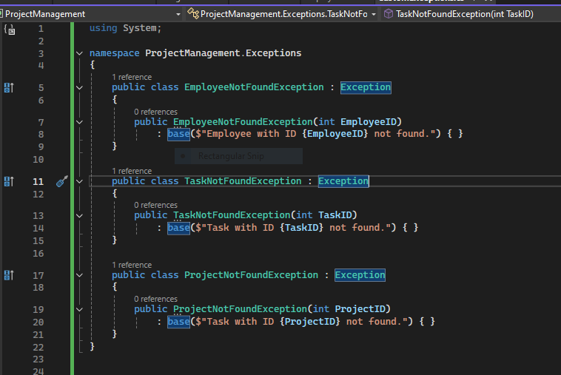

**MAIN PROGRAM**

using ProjectManagement.DAO;

namespace ProjectManagement

{

public class MainProgram

{

static void Main()

{

bool exit = false;

while (!exit)

{

Console.WriteLine("\n------ MENU ------");

Console.WriteLine("1. Add Project");

Console.WriteLine("2. Add Employee");

Console.WriteLine("3. Add Task");

Console.WriteLine("4. Assign project to employee ");

Console.WriteLine("5. Assign Task");

Console.WriteLine("6. Display Employee Details");

Console.WriteLine("7. Display Project Details");

Console.WriteLine("8. Display Task Details");

Console.WriteLine("9. Delete Employee");

Console.WriteLine("10. Delete Task");

Console.WriteLine("11. List all projects assigned with tasks to an employeee ");

Console.WriteLine("12. Exit");

Console.Write("Enter your choice: ");

string choice = Console.ReadLine();

switch (choice)

{

case "1":

Create.CreateProject();

Console.WriteLine("Project Created SucessFully");

break;

case "2":

Create.CreateEmployee();

Console.WriteLine("Employee Data Created SucessFully");

break;

case "3":

Create.CreateTask();

Console.WriteLine("Task Created Sucessfully");

break ;

case "4":

Assign.AssignProject();

break;

case "5":

Assign.AssignTask();

break;

case "6":

Display.DisplayEmployee();

break;

case "7":

Display.DisplayProject();

break;

case "8":

Display.DisplayTask();

break;

case "9":

Delete.DeleteEmployee();

break;

case "10":

Delete.DeleteTask();

break;

case "11":

Display.DisplayProjectAssigned();

break;

case "12":

exit = true;

break;

default:

Console.WriteLine("Invalid choice. Try again.");

break;

}

}

}

}

}

**OUTPUT**

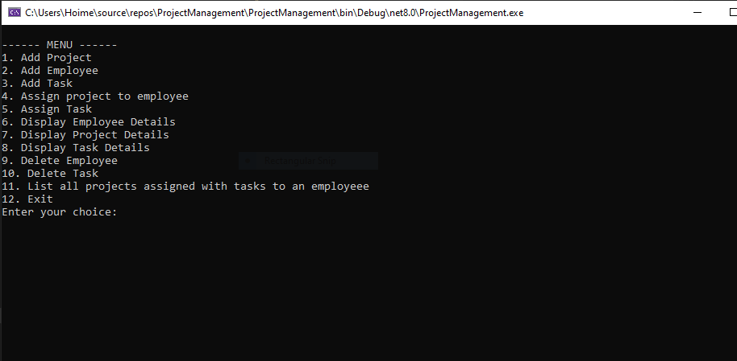

1. **Add Project**

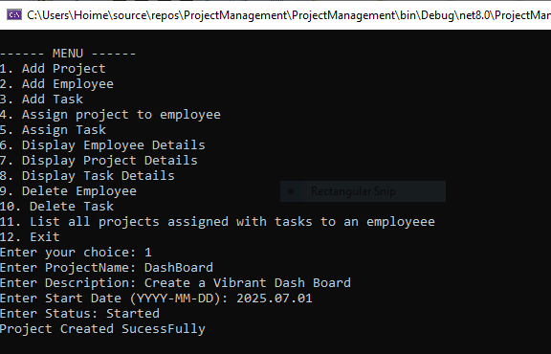

1. **Add Employee**

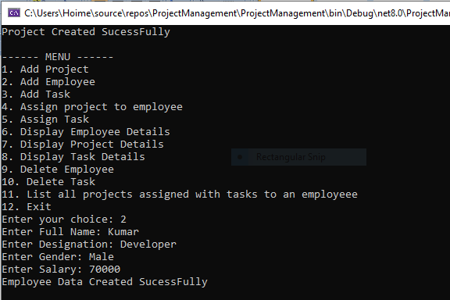

1. **Add Task**

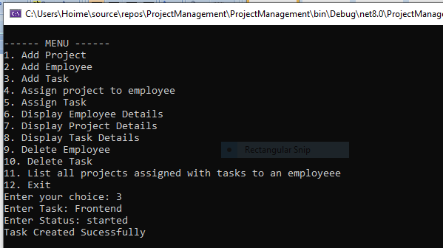

1. **Assign Project to Employee**

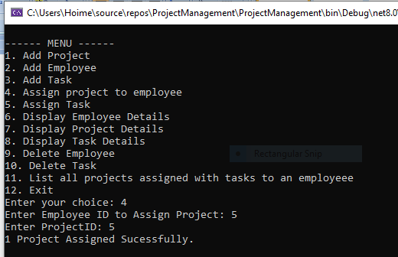

1. **Assign Task**

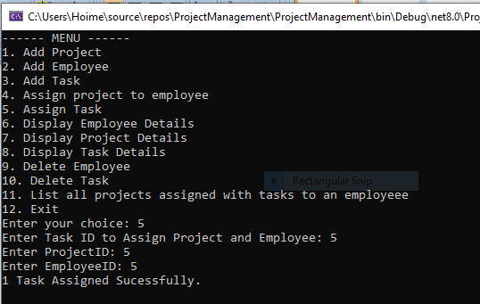

1. **Display Employee Details**

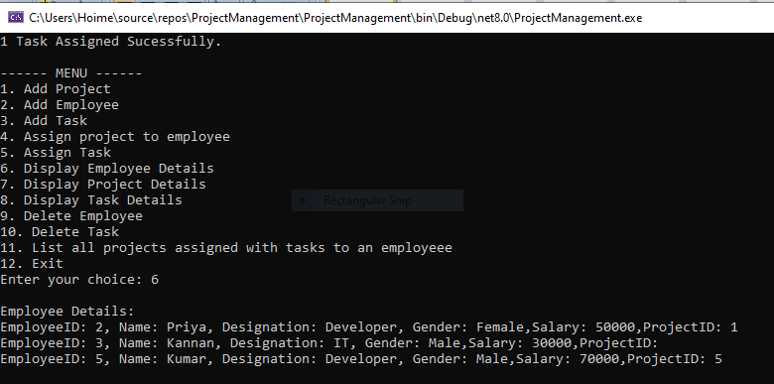

1. **Display Project Details**

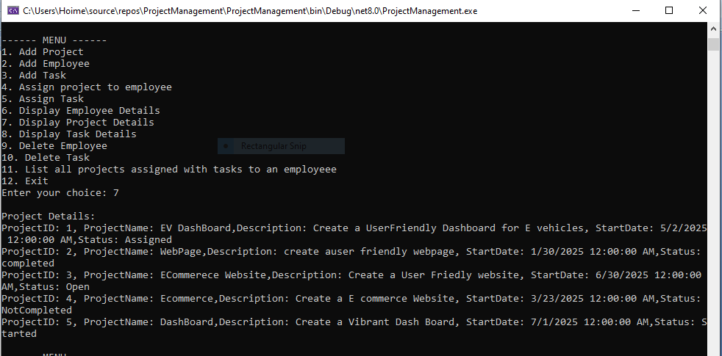

1. **Display Task Details**

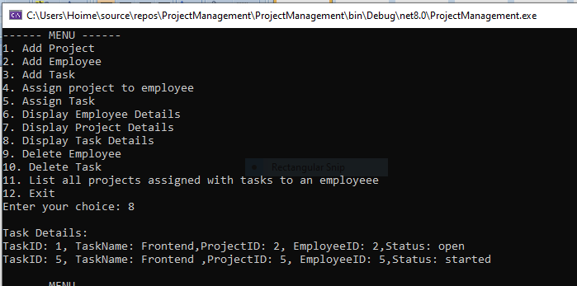

1. **Delete Employee**

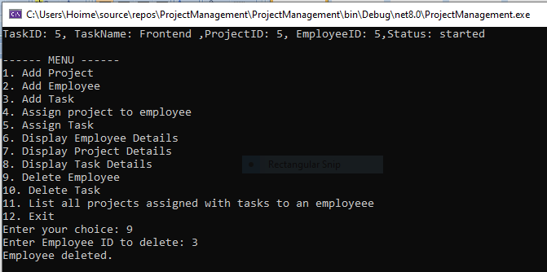

1. **Delete Task**

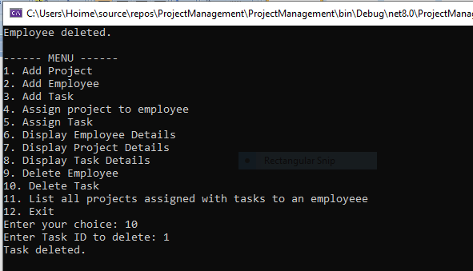

1. **List all projects assigned with tasks to an employee**

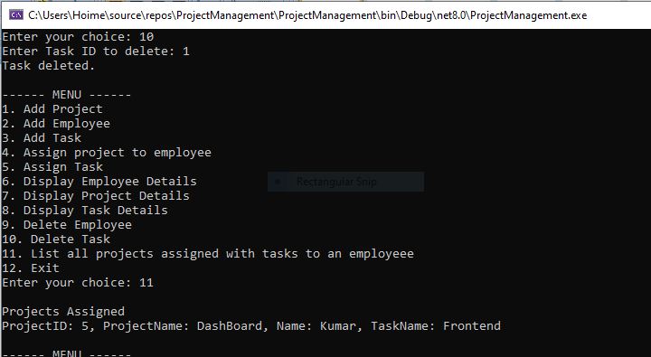

1. **Exit**

